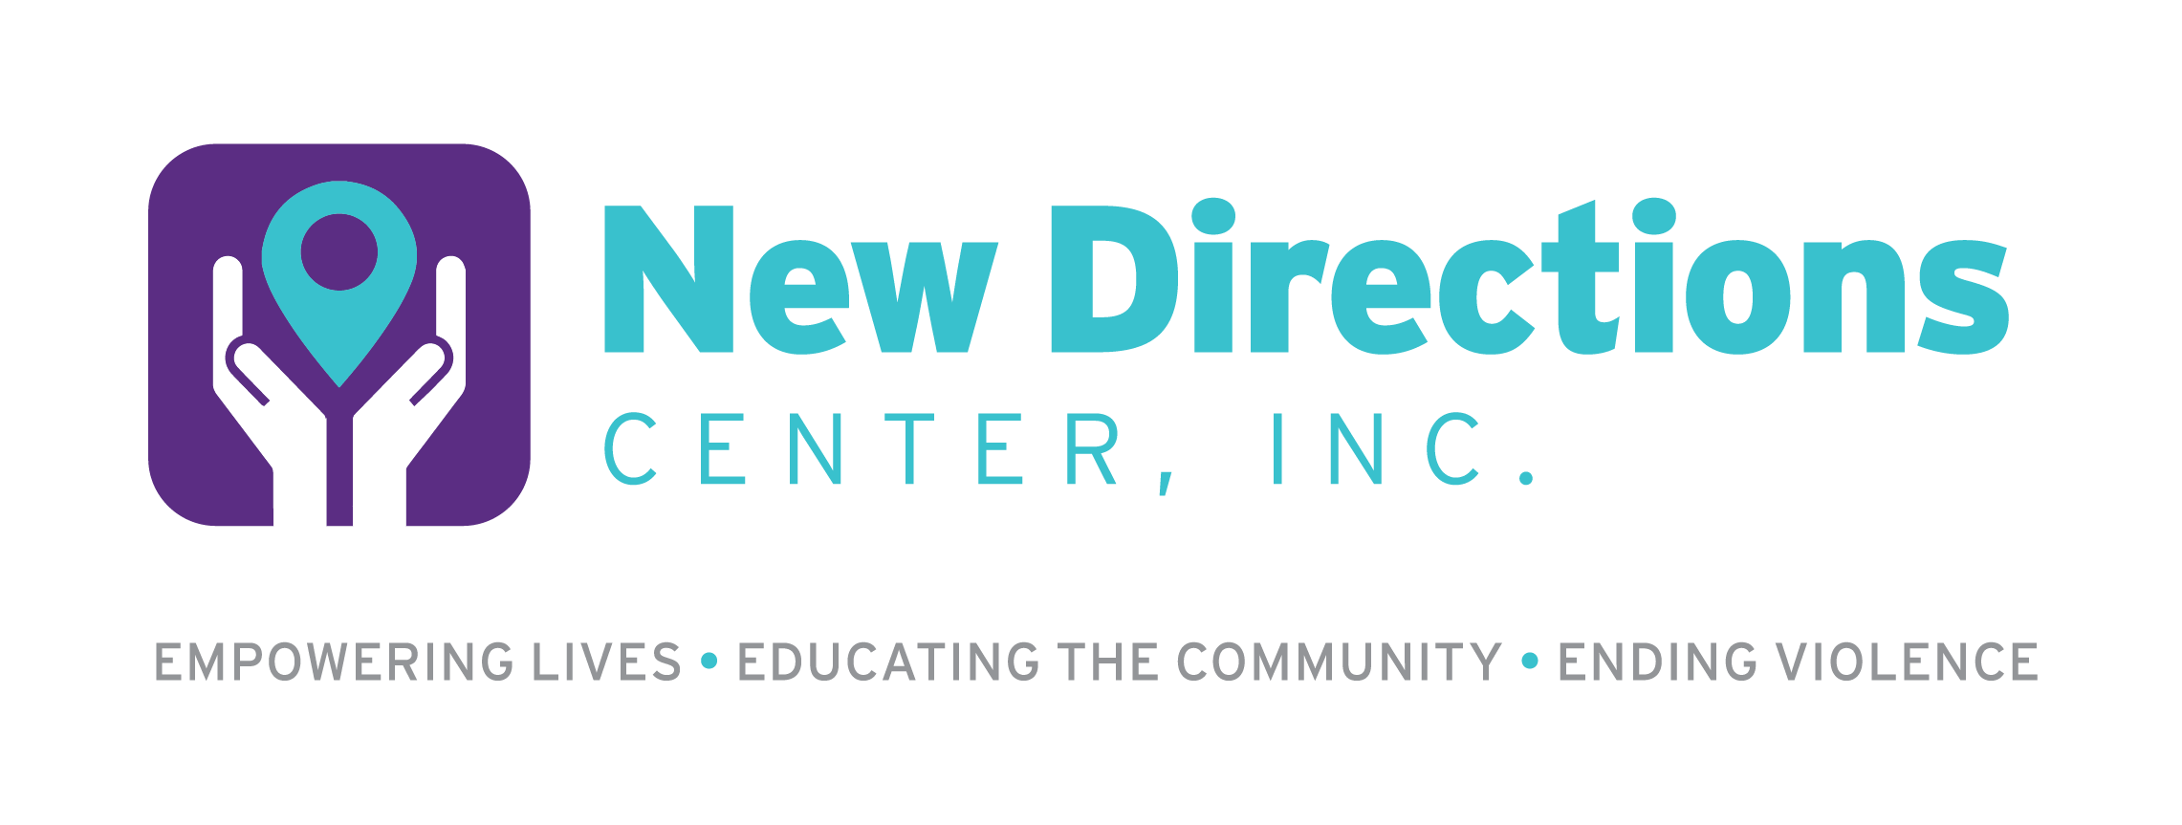

Volunteer Application

Name:_____________________________________________ Date: _____________
Address: _______________________________________________________________
Phone #: ______________________ Work #:______________________
Email address: __________________________________________________________
Occupation/Year in School:________________________________________________
Volunteer Availability: (Circle all applicable)
Number of days per week: 1 2 3 4 5
Monday Tuesday Wednesday Thursday Friday Saturday Sunday No Preference
Frequency (weekly, monthly, semi-monthly, etc.):

Why are you interested in volunteering with New Directions Center?

What types of work are you interested in doing with New Directions Center?

What would you like to gain personally from working with New Directions Center?

Please describe any previous volunteer experiences.

Please describe any previous work or volunteer experience related to domestic, dating, and sexual violence.
What personal strengths will you bring to this volunteer experience?

Describe particular skills/knowledge that you have that would be helpful in your volunteer position.

Are there any issues related to domestic, dating, or sexual violence that might be difficult for you to deal with during training or while working with us?

Are there any topics related to domestic, dating, or sexual violence that you would like to learn more about during training?

How did you learn about New Directions Center?

Have you been convicted of a crime in the past 5 years? If yes, what crime(s) have you been convicted of?

Professional References
1. Name:________________________________ Phone:____________________
Relationship to applicant:_____________________________________________

2. Name:________________________________ Phone:____________________
Relationship to applicant:_____________________________________________
All information about a volunteer is considered confidential and is to be released only to authorized personnel.
If under 18, you must be at least 16 years of age, with parental consent to volunteer.
Signature:________________________________________________________ Date:____________
Parent or guardian Signature:____________________________________________ Date:_________

Thank you for your interest in becoming a New Directions Center volunteer!

